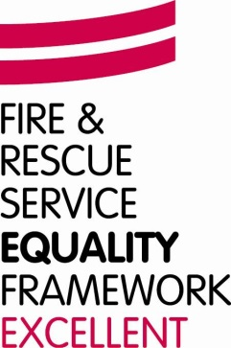
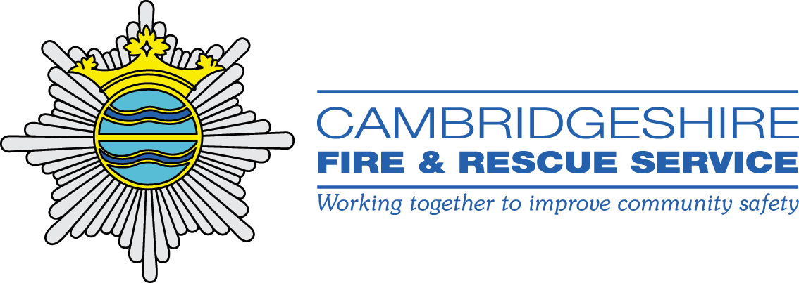

Guidance on improving spoken and written English to work in Cambridgeshire Fire and Rescue Service.

Introduction
To work in a customer facing role in a public authority in the UK (as firefighters do), you must be able to speak sufficient, fluent English to be able to carry out your role effectively. This is a requirement of the Immigration Act 2016.

This will usually be tested at interview by being asked, and expected to answer, standard interview questions.

The ability to read and understand English is also tested through the initial selection tests for a firefighter. The appropriate standard is considered to be B1 of the Common European Framework for Languages (CEFL).

The following information aims to signpost you to resources for improving your ability to speak and read / write English.

ESOL stands for English for Speakers of other Languages and courses are aimed at non-native English speakers. The main aim of ESOL courses is to help people settle into English-speaking countries and to be able to get by in everyday life. Teaching will cover everything from how to use the bus to what different ingredients are called in English supermarkets.

For more specialist vocabulary and understanding of Fire and Rescue Service related terms, you are encouraged to read articles and information available on our website.

There is a facility on our website to have the content translated into a language of your choice. This can be done by going to the bottom of the home page, clicking on “Language” to display a drop down menu and then selecting the language you want from the list. The content of the website will change into that language. This may help you to learn any specialist vocabulary relating to fire and emergency incidents and procedures.

Links to local colleges providing ESOL training and on-line resources for improving English.

Using English.com (on-line course) https://www.usingenglish.com/esl/students/

Cambridge Regional College: http://www.camre.ac.uk/course-search-ingle/?CC=MP1ESOLST&CB=ESOL%20Study%20Programme

Oasis Centre, Wisbech http://www.advicehub.org/latest-news/free-courses-at-the-oasis-community-centre-wisbech/

Rosmini Centre, Wisbech http://www.rosminicentrewisbech.org/latest-news.html

Cambridgeshire Fire and Rescue Service website http://www.cambsfire.gov.uk/

