

Firefighter Written Tests

PREPARATION AND
PRACTICE BOOKLET

Section One: Introduction

About this booklet

This booklet has been developed to help you prepare for the firefighter written tests which form part of our selection process for firefighters. This booklet is divided into eight sections:

- Introduction - this section introduces the tests and provides you with a brief description of what they are.

- Preparing for the tests - this section provides you with some general advice on preparing to take the tests.

- How to use the question booklets and answer sheets - all of the tests use multiple choice responses; this section gives guidance on how to use the question booklets and answer sheets.

- Practice questions for the working with numbers test - this section contains the instructions and some practice questions to help familiarise you with what to expect when you take the working with numbers test.

- Practice questions for the understanding information test - this section contains the instructions and some practice questions to help familiarise you with what to expect when you take the understanding information test.

- Practice questions for the situational awareness and problem solving test - this section contains the instructions and some practice questions to help familiarise you with what to expect when you take the situational awareness and problem solving test.

- Answers to the practice questions – this section contains the correct answers for the practice questions so that you can check your own answers.

- Frequently asked questions - this section includes answers to some questions you may have about the tests and testing sessions.

We strongly recommend you set aside some time to read through this booklet and practice questions prior to your test day.

Firefighter written tests

There are three tests in total;

- Working with numbers test. This is a timed test that lasts 45 minutes. Firefighters need to be able to make basic mathematical calculations, e.g. for interpreting gauges or calculating how much hose is needed at a fire. This test will examine these abilities.

- Understanding information test. This is a timed test that lasts 30 minutes. It assesses your ability to understand and interpret the type of written information that you may commonly come across as a firefighter.
- Situational awareness and problem solving test. This is a timed test that will last 35 minutes. This test is designed to assess your ability to ensure the safety of yourself and others and your ability to use information to solve problems.

More information about the format of the tests and what they measure is given in the practice section (Sections 4-6 of this booklet). The tests have been designed to be highly relevant to the work of firefighters. They use scenarios and questions that reflect the type of activities and decisions that firefighters may need to make on a routine basis. Each test has been fully trialled and tested, and your performance will be compared to a large group of comparable firefighter applicants. Whilst realistic and relevant to the firefighter role no specific knowledge or experience of being a firefighter is required to complete the tests. You will not be at a disadvantage if you do not have this knowledge or experience.

Each test is assessed separately, but will be looked at together to form an overall measure of your suitability to become a firefighter.

The tests are paper based and you will be given full instructions on how to complete each one before you take each test. An administrator will also be present at the testing session and will guide you on each stage of the process. At the beginning of each assessment there will be example questions to check that you have understood the instructions and to make sure you feel comfortable taking the test.

To help you prepare, Sections 4-6 of this booklet include examples of the instructions as you will see them on the actual tests.
Section Two: Preparing for the tests

There are a number of things you can do to help you prepare to take the firefighter written tests. We suggest you set aside some time to undertake the preparation described below.

General preparation

Ensure that you are comfortable with the administrative arrangements that have been made for you, if you are not, raise any concerns with the Recruitment.

In particular, check that you know:
- the date, time and location of the testing session (these will be detailed on your invitation letter); and
- the time it will take you to get to the venue and the travel arrangements you need to make.

If you have any special requirements, please ensure that you have informed the Recruitment Team in plenty of time prior to the event as per the invitation letter, so that the necessary arrangements can be made.

Complete the practice questions

In sections 4-6 of this booklet there are practice questions for each of the Tests. These are examples of the sort of questions that you will be asked. Whilst they are not the actual questions that you will be presented with, they will nevertheless give you a realistic preview of what you will encounter during the actual assessment. You should complete these as part of your preparation.

Remember:

- These questions are for practice only – they are not the questions you will be asked during the real assessment.
- Have a go at each of the practice questions – this will help you become familiar with the process and format of the questions.
- You may try them as often as you like.
- Your ‘results’ will not be collected or used by anyone – they are for your information only.

The day before

- Try not to dwell on the assessments or become anxious about them – stay relaxed and keep yourself occupied.
- Get plenty of rest and get a good night’s sleep.

On the day

- Allow plenty of time to get to the test venue – you will not be allowed to enter the test room if you arrive once testing has started.
- You do not need to bring paper, pencils, calculators or any other equipment as everything you need will be provided for you. Please note, you will not be permitted to use calculators for the purpose of the working with numbers test.
- Wear comfortable clothing.
- Do not drink alcohol or take any strong medication prior to the assessment session.
- Make sure that you are physically comfortable before the test session starts (visit the toilet, have a drink of water, make sure that you have eaten something etc.)

During the test session

- The session will run for about 3.5 hours in total.
- You will be given a break between the assessments.
- Ensure that you can see and hear the administrator comfortably and if not, tell them.
- Inform the administrator of anything personally significant, for example if you feel ill, are dizzy or have concerns before or during the test session.
- Listen carefully to the administrator as they explain the assessment procedure.
- Any instructions you need will be read by the administrator and will also be shown in your question booklets.
- Do not start the tests until you have been instructed to do so, and you are clear about what you are doing.
- At the start of each assessment you will be given one example question. Follow the instructions for these as they will be good practice for the assessment itself.
- If you are having trouble with the example questions, ask the administrator for help – ensure that you understand what they say as you will not be able to ask for help once the actual assessment begins.
- If at any time you are unsure about what you should be doing before the assessment begins – ask!

Section Three: How to use the question booklets and answer sheets

During the test session you will be given a question booklet and separate answer sheet for each of the tests. The first page of the booklet will contain information about the test and the instructions for completing it. Your administrator will read the instructions aloud. You will then have the opportunity to go through practice scenario and questions before starting the timed test.

Answering the questions

When responding to the questions:

- You should only use the information provided to answer the questions.

- Choose the correct answer from the four answers given and indicate it on the answer sheet. Fill the entire circle/square that corresponds to your answer pressing down hard on the paper to make as dark a mark as possible.

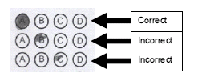

- If you make a mistake or change your mind and decide on another option please erase the mistake and fill the circle/square that corresponds to your revised answer.

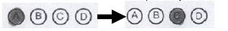

- Ensure that the mistake is completely erased, and NOT as shown below

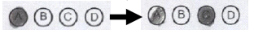

- If more than one square is filled and there is no indication that you have attempted to show one is incorrect you will receive no marks for that question.

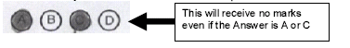

Each answer sheet will look like the example shown below. All answer sheets will have a similar format.

On the left of each set of response circles/squares is a number. During the tests you should ensure that this number corresponds to the number of the question you are answering.

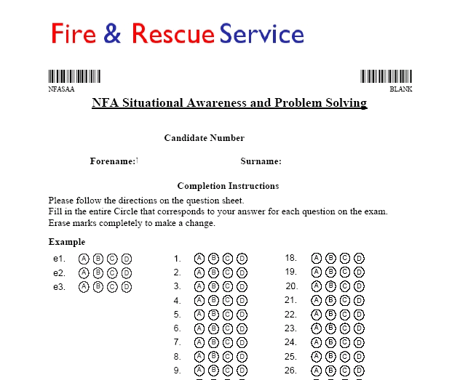
Section Four: Practice questions for the working with numbers test

This section contains the instructions and practice questions for the working with numbers test. It will help you familiarise yourself with the working with numbers test, so that you feel comfortable with the type and style of questions. The practice questions provided are realistic examples of the sorts of questions you will be asked but are not the actual questions you will see on the assessment day.

Overview of the working with numbers test

This is a timed test that lasts 45 minutes. Firefighters need to be able to make basic mathematical calculations, e.g. for interpreting gauges or calculating how much hose is needed at a fire. You will be presented with a number of scenarios that will show numerical information in a variety of formats from graphs to gauges. For each scenario you will be asked questions with multiple choice answers. On the day, you will not be allowed a calculator for the test but you will be provided with paper for your rough workings. To get maximum benefit from completing these practice questions, we suggest that you do not use a calculator.

Example Question

Below is the actual example that you will see in the working with numbers test. As you can see, information is presented and you have to answer multiple choice questions about that information. In this example we have presented one of the questions. In the practice session on your test day there will be more.

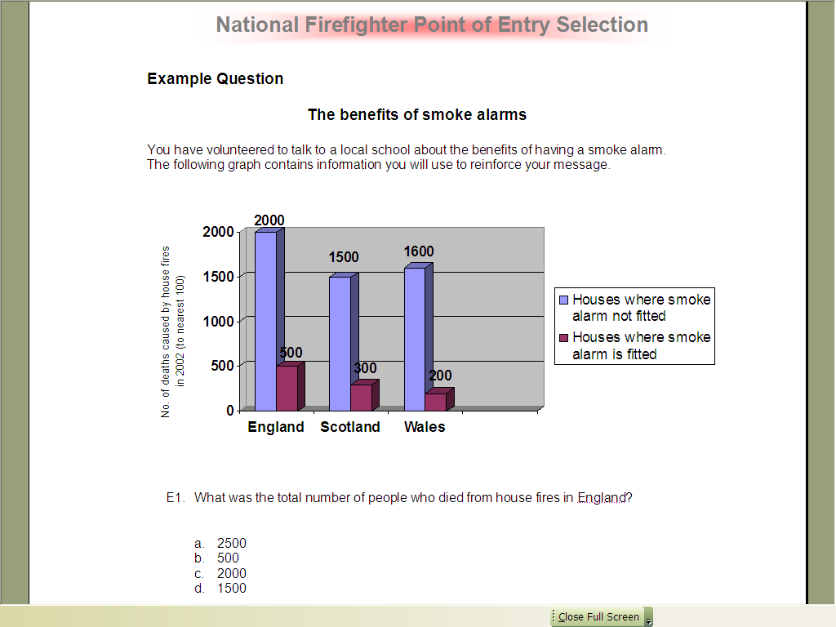

Remember, when responding to the questions:

- You should only use the information provided in the scenario to answer the questions.

- Choose the correct answer from the four answers given and indicate it by filling in the entire square that corresponds to your answer. Press down hard on the paper to make as dark a mark as possible.

Practice Questions

There are a series of practice scenarios and questions on the following pages. These are provided for you to familiarise yourself with the style and content of this test and to practice the kinds of questions you will see in the actual test. When you have completed the practice questions you can check your answers against those provided in section 7 of this booklet.

Practice Scenario 1: Cleaning the station

You’ve been asked to clean the floors of three rooms in your fire station: the training room; the canteen; and the changing area. A floor plan with the floor space of each room is shown below. In order to clean the floor you have a bucket that contains enough cleaning fluid for a floor space of 20m².

Floor plan

Training Room
100m²

Canteen
60m²

Changing Area
30m²

Please answer the following questions using the information above

- What is the total area of the floors you have been asked to clean?

a |  | 130m²
b |  | 160m²
c |  | 210m²
d |  | 190m²

- How many buckets of cleaning solution do you need to clean the training room floor?

a |  | 5
b |  | 6
c |  | 4
d |  | 3

- How many buckets of cleaning solution do you need to clean the canteen and the changing area floors?

a |  | 6
b |  | 3
c |  | 5
d |  | 4

- How many buckets of cleaning solution do you need to clean the training room and the canteen floors?

a |  | 7
b |  | 8
c |  | 9
d |  | 6

- How many buckets of cleaning solution do you need to clean the training room and the changing area floors?

a |  | 5
b |  | 6
c |  | 7
d |  | 8

- If you had enough cleaning solution to fill 10 buckets and you cleaned the canteen floor, how many buckets of cleaning solution would you have left?

a |  | 3
b |  | 4
c |  | 6
d |  | 7

- If you had enough cleaning solution to fill 13 buckets and you cleaned the training room floor, how many buckets of cleaning solution would you have left?

a |  | 5
b |  | 8
c |  | 6
d |  | 7

Practice Scenario 2: Using breathing apparatus

When firefighters tackle fires they sometimes wear air tanks to help them breathe. It is important that Firefighters ensure there is enough air left in the tank.

Please look at the information given below and answer the questions that follow.

A Firefighter needs to consider the following information when using an air tank:

- At what time he / she went into the fire

- What the time is now

- How much air (in minutes) was in his / her tank when he / she went into the fire

This information allows a firefighter to calculate how much air is left in an air tank. For example:

Time In | Time Now | Amount of air on entry (minutes) |  | Amount of air left (minutes)
9.00am | 9.30am | 60 |  | 30

Some of the following questions will be presented in this format. You should use the information presented to calculate how much air time you have left.

8. | Time In | Time Now | Amount of air on entry (minutes) |  | Amount of air left (minutes)
 | 10.20am | 10.40am | 50 |  | ?

a |  | 40 minutes
b |  | 30 minutes
c |  | 20 minutes
d |  | 10 minutes

9. | Time In | Time Now | Amount of air on entry (minutes) |  | Amount of air left (minutes)
 | 12.25pm | 12.55pm | 45 |  | ?

a |  | 30minutes
b |  | 25 minutes
c |  | 15 minutes
d |  | 20 minutes

10. | Time In | Time Now | Amount of air on entry (minutes) |  | Amount of air left (minutes)
 | 3.55pm | 4.15pm | 35 |  | ?

a |  | 15 minutes
b |  | 25 minutes
c |  | 10 minutes
d |  | 20 minutes

- It is 7.41am and you have 23 minutes of air left in your tank. When will you run out of air?

a |  | 8.04am
b |  | 8.01am
c |  | 8.03am
d |  | 7.54am

Practice Scenario 3: Fire safety leaflet supplies

You have been asked to manage the use of fire safety leaflets at your fire station. The supply book below shows the numbers of fire safety leaflets that were at your fire station at the end of June and the numbers of leaflets used by three people during July, August and September. It also shows the numbers of new leaflets delivered during that same period. Look at the extract from the supplies book below and answer the questions that follow.

Supplies

Total Number (at end of June)

ColourBlack & White

4002000
New deliveries

Colour Black
& White

Beginning July 500 1000

Beginning August 500 1500

Beginning September 190 1000

Usage
Colour Black & White
July

Pat50250

Mia100500

Tom150400

August

Pat80300

Mia100450

Tom140250

September

Pat100250

Mia110400

Tom150400

Please answer the following questions using the information above
- In total, how many colour leaflets were used in July?

a |  | 250
b |  | 300
c |  | 1150
d |  | 350

- How many black & white leaflets were used in August?

a |  | 320
b |  | 900
c |  | 950
d |  | 1000

- How many colour leaflets were used in August and September?

a |  | 680
b |  | 580
c |  | 670
d |  | 2050

- Who used the most leaflets in total in September?

a |  | Pat
b |  | Mia
c |  | Tom
d |  | Cannot say

- Of the 3 months, in which did Mia use most leaflets?

a |  | Cannot say
b |  | July
c |  | August
d |  | September

- How many black and white leaflets were left at the end of July?

a |  | 1850
b |  | 1950
c |  | 850
d |  | 1900

- How many leaflets did Tom use in total in July and August?

a |  | 840
b |  | 890
c |  | 940
d |  | 1150

- In August how many more black and white leaflets were delivered than used?

a |  | 400
b |  | 1000
c |  | 600
d |  | 500

- In September how many more colour leaflets were used than delivered?

a |  | 160
b |  | 170
c |  | 180
d |  | 190

Practice Scenario 4: Outdoor fires

Rubbish fires that are started deliberately can be a threat to life and a significant expense to property.

You have volunteered to talk to a local youth group about the dangers and consequences of starting rubbish fires. The following graphs contain information for last year that you will use to back up your talk.

Information about your local area

Month | Total outdoor fires | Rubbish fires
January  February  March  April  May  June  July  August  September  October  November  December | 250  400  350  275  425  300  375  425  350  450  525  200 | 10  5  4  4  4  15  10  20  5  5  40  10
Annual monthly average | 360 | 11

Information about the UK
0
200
400
600
800
1000
1200
Jan
Feb
Mar
Apr
May
Jun
Jul
Aug
Sep
Oct
Nov
Dec
All outdoors
Rubbish
Number of fires per day
Please answer the following questions using the information above
Grassland

- In the local area, how many rubbish fires were there in total in February and March?

a |  | 9
b |  | 8
c |  | 5
d |  | 10

- In the local area, how many outdoor fires were there in total in August and September?

a |  | 625
b |  | 800
c |  | 775
d |  | 675

- In the local area, which month had the greatest number of rubbish fires?

a |  | August
b |  | November
c |  | June
d |  | December

- In which month were there the least number of outdoor fires in the local area?

a |  | January
b |  | December
c |  | June
d |  | April

- In the local area, how many outdoor fires were there in total in March, April and May?

a |  | 1040
b |  | 950
c |  | 1025
d |  | 1050

- In the UK, which month had the least number of outdoor fires?

a |  | December
b |  | June
c |  | April
d |  | January

- In the local area, what was the total number of outdoor fires in the first three months?

a |  | 950
b |  | 900
c |  | 1000
d |  | 1025

Section Five: Practice Questions for the Understanding Information Test

This section contains the instructions and practice questions for the understanding information test. It will help you familiarise yourself with the understanding information test, so that you feel comfortable with the type and style of questions. The practice questions provided are realistic examples of the sorts of questions you will be asked but are not the actual questions you will see on the assessment day.

Overview of the understanding information test

This is a timed test that lasts 30 minutes. It assesses your ability to understand and interpret the type of written information that you may commonly come across as a firefighter. You will be presented with a number of scenarios; the format of the scenario will vary and may, for example, be presented as a memo, newsletter or safety information. Each scenario is followed by a number of multiple choice questions that you should answer using the information contained in the scenario alone.

Example Question

Overleaf is the actual example that you will see in the understanding information test. As you can see, information is presented and you have to answer multiple choice questions about that information. In this example we have presented one of the questions. In the practice session on your test day there will be more.

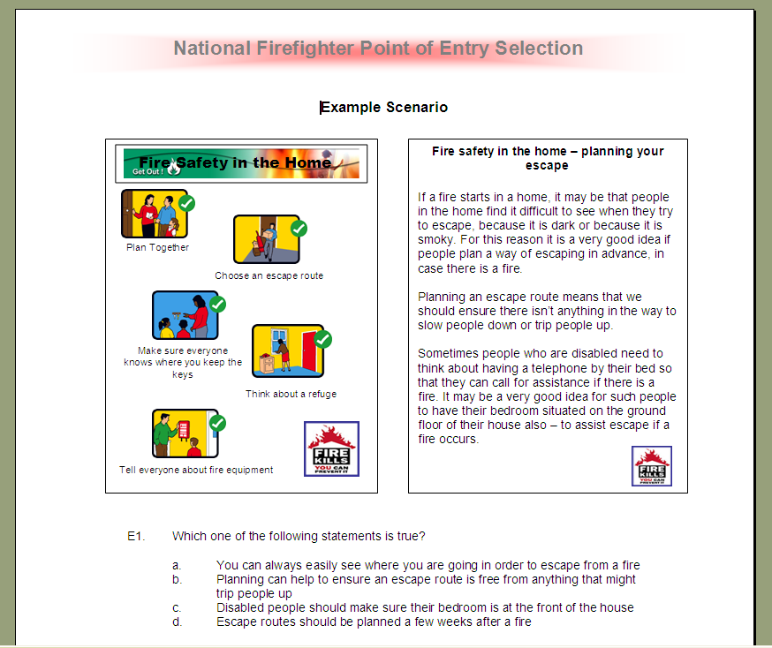

Remember, when responding to the questions:

- You should only use the information provided in the scenario to answer the questions.

- Choose the correct answer from the four answers given and indicate it by filling in the entire circle that corresponds to your answer. Press down hard on the paper to make as dark a mark as possible.

Practice Questions
There are a series of practice scenarios and questions on the following pages. These are provided for you to familiarise yourself with the style and content of this test and to practice the kinds of questions you will see in the actual test. When you have completed the practice questions you can check your answers against those provided in section 7.

Practice Scenario 1: Fire Safety at Home

After a fire in the home

If someone experiences a fire in their home there are a number of things they should consider after the fire has been put out by the Fire and Rescue Service.

It may be that the home is no longer secure because doors or windows have been damaged. If this is the case, windows may need to be boarded up or doors may need to be replaced. The police or local council may be able to provide names of companies that can carry out this work. It may also be a good idea to remove valuables and important documents from the home until the home is made completely secure.

Another task to consider is the cleaning up of the home. Furniture should be wiped down and left to dry. Walls and ceilings can be cleaned with washing up liquid. Sometimes specialist cleaning firms can be hired to assist the homeowner.
Fire Safety in the Home

1. According to the article:

a |  | Fire damage can affect the security of a home
b |  | The insurance company will want to see an accurate fire report
c |  | The local council will carry out work to make a home secure after a fire
d |  | Homeowners should always consult a specialist cleaning firm after a fire

2. The article suggests that:

a |  | All doors should be made from fire resistant material
b |  | Valuables and documents may be at risk in a home with fire damaged  windows or doors
c |  | Boarded up windows are more secure than normal windows
d |  | Walls and ceilings should only be cleaned with washing up liquid

3. Which one of the following statements is false?

a |  | The police and local council may know companies who can repair damaged windows or doors
b |  | Specialist cleaning firms may be able to help the owner of a fire damaged home
c |  | Furniture should be wiped down and polished immediately
d |  | The homeowner may need to do a number of things if they experience a fire in their home

4. The article refers to which one of the following:

a |  | Firefighters have a duty to limit the amount of damage caused to a property
b |  | The cleaning up the homeowner may need to do after a home fire
c |  | The role of the police during a home fire
d |  | The increased incidence of crime at homes damaged by fire

5. Which one of the following statements is true?

a |  | The police may know of companies who can replace fire damaged doors
b |  | Fire-damaged doors should always be cleaned with washing-up liquid
c |  | Specialist cleaning firms will be provided by the local council after a domestic fire
d |  | The Fire and Rescue Service will work with the police to make sure that a home is made completely secure after a domestic fire

6. Which one of the following statements is true?

a |  | The Fire and Rescue Service will deal with all consequences of a domestic fire
b |  | The police have a responsibility to help victims of domestic fires
c |  | It is necessary to allow furniture to dry out
d |  | The police will look after valuables while homes are being made secure after domestic fires

7. Which one of the following statements is suggested by the article?

a |  | Specialist cleaning companies will use industrial detergent to clean walls and ceilings after a fire
b |  | Local police will insist that specialist cleaning companies are used following a domestic fire
c |  | The local council may be able to let you know of companies who can board up windows
d |  | There are specialist firms who will safeguard important documents while houses are being made habitable again after suffering fire damage

8. The article suggests that:

a |  | The Fire and Rescue Service will clean fire damaged homes
b |  | All doors and windows should be replaced after a fire
c |  | Water can cause more damage to a home than fire
d |  | Fire can damage doors and windows

Practice Scenario 2: Fire and Rescue Service Manual

Fire and Rescue Service Training Manual
Health and Safety

It is important that Firefighters work in an environment that is healthy and safe as far as possible. Some of the responsibility for this rests with the Fire and Rescue Service (FRS), but also with the individual employee themselves.

The FRS is expected to provide:
Buildings and equipment that are in a good state of repair.
A healthy environment in terms of heating, lighting, ventilation and noise levels.
Relevant information and training.

The employee must:
Take care of their own safety and that of others.
Neither interfere nor misuse anything provided for health and safety.
Inform their employer (the FRS) of any dangerous work situation or risks to health.

Only with the joint co-operation of the FRS and the employee can the workplace be made safe.

The FRS has issued a written policy on health and safety in the workplace and Firefighters are kept updated about policy changes through station notice boards.

9. According to the extract:

a |  | Firefighters are not responsible for the safety of others
b |  | The Health and Safety Officer is responsible for reporting dangerous work situations
c |  | Health and safety responsibilities are shared between the Brigade and the employee
d |  | Health and safety does not relate to the work environment

10. The extract suggests that Firefighters must:

a |  | Provide relevant information and training
b |  | Inform the Brigade if their work environment suffers from noise that may damage their health
c |  | Wear protective fire gear at all times
d |  | Modify health and safety equipment to improve effective working

11. Where can Firefighters find updates to their Brigade’s health and safety policy?

a |  | Team briefings
b |  | Safety briefings
c |  | Health and safety website
d |  | Station notice board

12. The Fire and Rescue Service has a responsibility to:

a |  | Work with employees to maintain health and safety at work
b |  | Provide equipment in a good state of repair only if the budget allows
c |  | Encourage Firefighters to provide relevant information and training
d |  | Make no changes to the health and safety policy

13. Which one of the following is not relevant to health and safety within the Fire and Rescue Service?

a |  | Buildings and equipment
b |  | Computer skills training
c |  | Station notice boards
d |  | Ventilation

14. Which one of the following statements most accurately summarises the extract?

a |  | Health and safety in the Fire and Rescue Service (FRS) is the joint responsibility of the employee and the FRS
b |  | The FRS written policy determines the safety of the FRS environment
c |  | The FRS can only make its working environment safe to a limited extent
d |  | Employees have more responsibility for their own health and safety at work than the FRS itself

- Which one of the following statements is true?

a |  | Employees are not responsible for ensuring that their working environments are safe and healthy
b |  | Firefighters must only ensure that their own safety is taken care of
c |  | Employees must not misuse anything provided for Health and Safety
d |  | Employees are expected to keep quiet about unsafe working environments

16. Which one of the following statements is false?

a |  | Firefighters must not meddle with health and safety equipment
b |  | Firefighters must let the Fire and Rescue Service know if anything happens at work which could be dangerous
c |  | Firefighters’ actions are more important than those of the Fire and Rescue Service to ensure safe and healthy working
d |  | The written policy on health and safety in the workplace is subject to change from time-to-time

17. The extract suggests that every Firefighter must:

a |  | Take action to ensure the safety of themselves and others
b |  | Ignore faulty equipment
c |  | Develop a separate policy on first aid for work-related accidents
d |  | Train staff in effective working practices

Practice Scenario 3: Trapped During a Fire

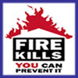

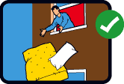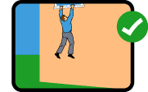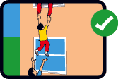

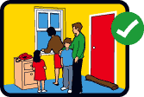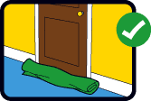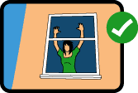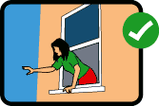

If someone finds themselves trapped in a room because of a fire it is important that the person remains calm, although it is not easy to do so.

The first thing the person should do is to make sure doors are closed to help stop the fire coming into the room. A towel or sheet can be used to block any gap at the bottom of the door.

If smoke gets into the room the person trapped should go down to the floor – this is to make it easier to breathe as smoke will tend to rise upwards.

It is also suggested that the person go to a window and open it to allow them to attract the attention of anyone outside. The Fire and Rescue Service should arrive shortly after. If the person has to jump from the building, cushions can be dropped to help break their fall.

What to do if you are trapped in a room during a fire

- The first thing a person should do if trapped in a room because of a fire is:

a |  | Lie down on the floor
b |  | Open a door
c |  | Put a towel around his/her head
d |  | Close the doors to the room

19. The article suggests that:

a |  | A closed door will ensure that no smoke enters a room
b |  | Smoke may get into a room from gaps at the bottom of a door
c |  | The Fire and Rescue Service will arrive immediately if a person is trapped in a room
d |  | Opening a window may let more air into the room and make the fire worse

20. Which one of the following statements is true?

a |  | Everyone will panic if trapped in a room during a fire
b |  | Opening a window may make it easier to attract the attention of passers by
c |  | There is likely to be more smoke on the floor than near the ceiling
d |  | Closing the door will stop any smoke from coming into the room

21. Which one of the following is suggested in the article?

a |  | Not everyone who gets trapped in a room during a fire manages to survive in the escape
b |  | Sometimes a person may be left with no choice but to jump out of a window if trapped in a burning building
c |  | Towels and sheets can be used to clean up after a fire
d |  | The fire brigade often arrives shortly after a fire has broken out

22. Which one of the following statements is false?

a |  | Cushions are no use at all if trapped in a room because of a fire
b |  | It is important that a person remains calm if trapped in a room because of a fire
c |  | Attracting the attention of passers by may encourage them to call the fire brigade
d |  | It is important to avoid smoke if trapped in a room because of a fire

23. In the event of smoke getting into a room, which of the following is the best thing to do?

a |  | Stand by the window
b |  | Go down to the floor
c |  | Get on top of a table or chair
d |  | Open the door

24. Why should people open a window if trapped in a room during a fire?

a |  | The fresh air will help to cool down the heat of the fire
b |  | They can attract the attention of passers-by
c |  | To reduce the likelihood of the glass exploding
d |  | To make it easier to breathe

25. According to the article, how can fire be prevented from coming into a room?

a |  | Shutting the door
b |  | Placing a wet towel in the path of the fire
c |  | Shutting any windows to reduce air circulation
d |  | Calling the fire brigade

26. Which one of the following is not recommended in the event of being trapped in a room because of a fire?

a |  | Remain calm
b |  | Block gaps at the bottom of the door with sheets
c |  | Opening any windows
d |  | Jumping from the building as soon as possible

Practice Scenario 4: Hazards of Firefighting

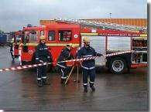
THE HAZARDS OF FIREFIGHTING

Firefighters may come to harm through a variety of possible hazards. Normally
these dangers are kept to a minimum.

Potential hazards include human errors (such as turning a valve the wrong way or misreading a dial on a piece of equipment), or through intentionally taking risks.

It may also be that a Firefighter does not have enough information or experience to do something, which may lead to a problem. Information may sometimes be misheard or misunderstood which also may lead to danger.

Harm could occur because a Firefighter is tired, has too much work or because of poor visibility.

In addition, there may be problems at a fire which leads to danger – such as flammable liquids, dangerous chemicals or vandalism caused by others.

27. Which of the following is not mentioned in the extract specifically as a possible hazard to Firefighters?

a |  | Human error
b |  | Breaking the rules
c |  | Lack of information
d |  | Misheard information

- Which of the following is likely to help a Firefighter avoid danger?

a |  | A wide range of firefighting experience
b |  | Intentionally taking risks
c |  | Working hard despite feeling tired
d |  | Poor visability

29. Which one of the following may lead to danger during a fire?

a |  | A good night’s sleep
b |  | Dangerous chemicals
c |  | Avoiding unnecessary risks
d |  | Young members of the public

30. According to the article, turning a valve the wrong way can best be described as:

a |  | Taking an intentional risk
b |  | Being caused by a lack of information
c |  | Keeping the danger to a minimum
d |  | Human error

31. If a Firefighter has too much work, s/he:

a |  | Is likely to be respected more by her/his team
b |  | Will get the job done more quickly
c |  | Might cause or come to harm during an incident (eg a fire)
d |  | May take an intentional risk

32. If a Firefighter mishears information the consequences might be:

a |  | An increase in the amount of flammable liquid at a fire
b |  | S/he has too much work
c |  | S/he becomes too tired
d |  | A dangerous situation

33. Which of the following most accurately summarises the article?

a |  | There are a number of different hazards in firefighting which may lead to harm
b |  | The biggest risks to Firefighters are caused by hazards over which they have no control
c |  | Human error has a greater impact on Firefighters’ safety than factors external to them
d |  | It is the responsibility of all Firefighters to minimise the number of hazards in their working lives

Section Six: Practice Questions for the Situational Awareness and Problem Solving Test

This section contains the instructions and practice questions for the situational awareness and problem solving Test. It will help you familiarise yourself with the situational awareness and problem solving test, so that you feel comfortable with the type and style of questions. The practice questions provided are realistic examples of the sorts of questions you will be asked but are not the actual questions you will see on the assessment day.

Overview of the situational awareness and problem solving test

This test is designed to assess your ability to ensure the safety of yourself and others and your ability to use information to solve problems. In the testing session you will be presented with 30 scenarios and you will have 35 minutes to complete the test. For each scenario, you will be asked to choose what your most likely response would be selecting from 4 alternative answers. At times it may be difficult to choose but you need to answer all questions. No specific training or knowledge is needed to answer the questions. You should read each scenario carefully and decide what you would do using only the information provided in the scenario.

Example Question Page

Below is the actual example that you will see in the situational awareness and problem solving test. As you can see, information is presented and you have to answer multiple choice questions about that information. In this example, we have presented one of the questions. In the practice session on your test day there will be more.

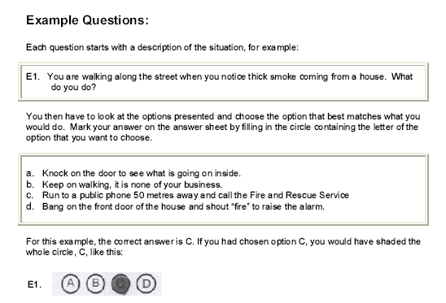

Remember, when responding to the questions:

- You should only use the information provided in the scenario to answer the questions.

- Choose the correct answer from the four answers given and indicate it by filling in the entire square that corresponds to your answer. Press down hard on the paper to make as dark a mark as possible.

Practice Questions

There are a series of practice scenarios and questions on the following pages. These are provided for you to familiarise yourself with the style and content of this test and to practice the kinds of questions you will see in the actual test. When you have completed the practice questions you can check your answers against those provided in section 7.

- You are called to a road traffic accident where a car has crashed into a tree. There is a police officer at the scene. A young girl has been rescued from the car by a passer-by, and is very upset. Her father and mother are still trapped and seriously injured. It will take all of your team to rescue the mother and father quickly. What do you do?

a |  | Leave the child and concentrate on rescuing the parents in the car as they are most at risk.
b |  | Focus on comforting the child while my colleagues rescue the parents.
c |  | Ask the police officer to comfort the child, while I help my team rescue the parents in the car.
d |  | Put the child in the fire engine so that she is safe and then help my team rescue the parents in the car.

- You attend a fire in an old block of flats. While fighting the fire inside the building you notice that there is a lot of water building up in the centre of the block, while rooms near the outside walls contain far less water. The ceiling is also starting to fall down. What do you do?

a |  | Continue to fight the fire and do not worry about the water. Large amounts of water are always necessary to fight a fire
b |  | Inform my manager of this information so that they can assess the risk of the building collapsing.
c |  | Keep fighting the fire but avoid the deep water at the centre of the building. Old buildings generally sag in the middle
d |  | It is not unusual for parts of the ceiling to fall down in a fire. I would take care that nothing falls on me.

- You are at a large factory fire that you are helping to put out. Your manager tells you to use your hose to put water on the fire in a particular area. You do as you are instructed, but after a while the fire becomes more intense in another area nearby. What would you do?

a |  | Put the water where the fire is more intense.
b |  | Keep putting the water on the same area and keep an eye on where the fire is getting stronger. If it continues to get stronger I will tell my manager.
c |  | Keep putting the water on the same area because I’ve been told to do it like this by my manager.
d |  | Stop what I am doing and go to find my manager to ask him what I should do.

- You are working away from your normal fire station for a month and not due to visit there for a week. You speak briefly to a colleague on the phone and she tells you that new information has been put on the notice board at your fire station but that it is not very interesting. What do you do?

a |  | Check the notice board when I am next at my fire station.
b |  | Wait for my manager to contact me. If the new information is important she will contact me soon.
c |  | Thank my colleague and not think any more about the new information.
d |  | Visit my fire station tomorrow and check the notice board for myself.

- It is midnight and you are called to a house where a father has locked himself out leaving his two year old locked inside. He took the child into the house, put his house keys down, and then went to the car to collect something. While he was out of the house the child closed the front door. The father called the Fire and Rescue Service two hours after this happened, and the child is now crying and very upset. The father is extremely agitated because he cannot get into the house to look after his child. What would you do?

a |  | Quickly find an alternative means of access that does not scare the child, or damage the property, so that it will be safe overnight.
b |  | Break down the door to rescue the child as soon as possible, because the father is very worried.
c |  | Wait for the police and let them break into the house.
d |  | Tell the Father to call for a locksmith.

- It is night time and you attend a house fire, where you can see flames on the ground floor and smoke coming from windows on the second floor. Two pairs of Firefighters are sent into the house to fight the fire on the ground floor. A neighbour then tells you that there may be two children upstairs. It is your responsibility to decide what to do. What do you do?

a |  | Tell both pairs of Firefighters to go upstairs quickly and search for the children.
b |  | Tell the neighbour that you know how to do your job and that if there are any children in the house they will be found.
c |  | Tell one pair of Firefighters to go upstairs with a hose to look for the children, while the other pair keep fighting the fire downstairs.
d |  | Tell both teams to concentrate on fighting the fire and then get them to search for the children after the fire has been put out.

- You are in your manager’s office at the fire station and you notice a computer and other power cables all plugged into one extension socket. This could potentially be dangerous. What do you do?

a |  | Do nothing but tell other people at the fire station about the danger and hope that the message will get back to my manager.
b |  | Move the cables when your manager is next out of the office.
c |  | Say and do nothing because my manager knows what he is doing.
d |  | Say something to your manager about the potential dangers and suggest that the cables are rearranged.

- You are in charge of managing a crowd that has gathered to watch a house fire. So far the crowd have been calm, but they suddenly become aggressive and shout insults at one of the casualties being rescued from the house. The insults are distressing the casualty. What do you do?

a |  | Do nothing – the crowd will get bored of shouting insults soon.
b |  | Do nothing – it is not my job to tell people what they can and can not say.
c |  | Talk assertively to the crowd and tell them to move away from the scene because they are causing a disturbance.
d |  | Ask my manager what to do.

- You are called to an incident where a car has crashed into a deep, fast flowing river. When you arrive you see a man has escaped from the car but is having trouble swimming to the river bank. You are worried that unless something is done the man will drown. It is essential that Firefighters do not enter deep water unless they are wearing a buoyancy aid, as it may put them in danger. You have no buoyancy aids on your fire engine. What do you do?

a |  | Shout for the man to be calm and swim to the bank.
b |  | I’m a good swimmer. I would tie a rope around my waist and then go into the river to rescue the drowning man. My colleagues would hold onto the rope.
c |  | I’m a good swimmer. I would strip off all my heavy clothes and then swim out to rescue the drowning man.
d |  | Throw ropes to the drowning man and shout for him to grab hold. When he has got hold of the rope I would pull him out. I would only enter the water as a last resort.
- You are asked by your manager to order fire safety leaflets because she is very busy. She normally orders a standard number each month, but this month a new fire safety initiative has been launched. She has told you to decide how many leaflets are ordered. When you ask a colleague her view she suggests ordering the same amount of leaflets because Firefighters make the same number of community fire safety talks each month. What do you do?

a |  | Order the same amount because a colleague tells me to do so.
b |  | Order the same amount because the leaflets cost a lot of money and it would be a waste if a lot were thrown away.
c |  | Order slightly more of the leaflets in preparation for the new initiative.
d |  | Order less leaflets because the new initiative will be more successful at promoting fire safety than leaflets will be.

- You have been asked to do an important task by your manager. A colleague then asks you to give an important but non urgent message to another colleague. What do you do?

a |  | Tell my colleague that I will pass the message on as soon as I have finished the task for my manager.
b |  | Stop what I am doing, give the message to the other colleague and then finish the task for my manager.
c |  | Tell my colleague that I am very busy and that I can not pass the message on.
d |  | Tell my colleague that I am very busy and that she should do it herself.

- You are the pump attendant at a house fire. You are responsible for checking the pressure of water being delivered to the hoses to ensure that there is enough water to put out the fire. You do this by looking at the pressure dials on the fire engine. How often do you check the dials?

a |  | Every so often when I get a chance.
b |  | When my colleagues tell me that they are running out of water.
c |  | Continuously.
d |  | When my manager tells me.

- You and another Firefighter are in a factory fighting an industrial fire. In this situation Firefighters use their radios to tell others on the outside what is going on. In terms of how often you would use your radio, which of the following options would be the best to do?

a |  | I would not bother using the radio. If there is any danger my partner will report it.
b |  | I would report in every few minutes to give those outside an update.
c |  | I would only use the radio when I’m in danger.
d |  | I would report in if I found a casualty.

- You are called to a fire in a semi-detached house where a man has been reported to be inside. The fire is burning strongly and is in danger of spreading. The neighbour who called the Fire and Rescue Service is outside the house. You are the first Firefighter into the house and you find the man in a chair. His clothes have been burned from his body and his skin is badly burnt. You check and find that he is dead. The man’s wife is on the other side of the road from the house being comforted by neighbours. What do you do?

a |  | Pick up the dead man and take him out of the building, and then return to put out the fire.
b |  | Leave the body where it is and carry on fighting the fire. I would inform my manager using my radio that the man was dead so that she could inform the wife.
c |  | Ask the neighbour outside the house to go over and tell the wife that her husband is dead. News like that is best coming from someone they know.
d |  | Stop fighting the fire, leave the building and go back to the fire engine. The man is dead so I cannot do any more.

- You are talking to a friend in her garage when you notice some broken glass on the ground. You are concerned that someone could cut themselves if they fall on the glass. What do you do?

a |  | Tell my friend that the glass is dangerous and persuade her to remove it safely.
b |  | Do nothing because it is not my business what my friend does in her garage.
c |  | Do nothing because I could hurt myself picking up the glass.
d |  | Use my hands to pick up the glass and put it in a nearby bin.

- You were off ill one day when a team meeting was held at your Fire Station. When you ask a colleague what went on in the team meeting, she tells you that it was boring and nothing new or important came up. What do you do?

a |  | Make sure that I am at all team meetings in the future.
b |  | Check with my manager what went on in the meeting.
c |  | Don’t check what went on in the meeting. If anything important happened another colleague or my manager will tell me.
d |  | Take the colleague at her word and don’t check what went on in the meeting.

- You have been asked by your manager to sweep the fire station yard of all dirt and leaves. You start sweeping the yard at one end and soon afterwards a colleague tells you he is going to use the other end for an exercise. It would be best if this end of the yard was clear of dirt and leaves before the exercise started. What do you do?

a |  | Continue to sweep from where I started - the colleague should have told me earlier if he wanted the other end clear.
b |  | Continue to sweep from where I started but work more quickly so that I reach the other end sooner.
c |  | Start sweeping the yard at the other end so that it is clear before the exercise starts.
d |  | Continue to sweep from where I started and tell my colleague that the other end of the yard will not be clear for a little while.

Section Seven: Answers to the Practice Questions

Working with Numbers Test

- Answer d
100m²+ 60m² + 30m² = 190m²

- Answer a
100m² / 20 = 5

- Answer c
60m²+ 30m² = 90m², 90m² / 20m² = 4.5 = 5 buckets

- Answer b
100m² + 60m² = 160m², 160m² / 20m² = 8 buckets

- Answer c
100m² + 30m² = 130m², 130m2 / 20m2 = 6.5 = 7 buckets

- Answer d
60m² / 20m² = 3, 10 – 3 = 7 buckets

- Answer b
100m2 / 20m2 = 5, 13 – 5 = 8 buckets

- Answer b
20 minutes have elapsed since entry, 50 – 20 = 30 minutes

- Answer c
30 minutes have elapsed since entry, 45 – 30 = 15 minutes

- Answer a
20 minutes have elapsed since entry, 35 – 20 = 15 minutes

- Answer a
If it is 7.41 a.m. there are 19 minutes until 8.00 a.m. (60 – 41=19), add the remaining 4 minutes (23 – 19 = 4) to 8.00 a.m. and the time the air will run out is 8.04 a.m.

- Answer b
50 + 100 + 150 = 300
- Answer d
300 + 450 + 250 = 1000

- Answer a
80 + 100 + 140 + 100 + 110 + 150 = 680

- Answer c
(Pat, 100 + 250 = 350) (Mia, 110 + 400 = 510), (Tom, 150 + 400 = 550)

- Answer b
(August, 100 + 450 = 550) (September 110 + 400 = 510) (July, 100 + 500 = 600)

- Answer a
There were 2000 black and white leaflets at the end of June, and then there was a delivery of 1000 at the beginning of July. Therefore there were 3000 black and white leaflets at the beginning of July. In July 1150 black and white leaflets were used (250 + 500 + 400 = 1150). Therefore at the end of July there were 1850 black and white leaflets left (3000 – 1150 = 1850)

- Answer c
(July, 150 + 400 = 550) (August, 140 + 250 = 390) (390 + 550 = 940)

- Answer d
1000 black and white leaflets were used in August (300 + 450 + 250 = 1000). 1500 black and white leaflets were delivered. Therefore 500 more leaflets were delivered than used (1500 – 1000 = 500).

- Answer b
In September 190 colour leaflets were delivered. In the same month 360 colour leaflets were used (100 + 110 + 150 = 360). Therefore 170 more colour leaflets were used than delivered (360 – 190 = 170)

- Answer a
5 + 4=9

- Answer c
425 + 350 = 775

- Answer b
November

- Answer b
December

- Answer d
350 + 275 + 425 = 1050

- Answer a
December, this shows the lowest point on the solid line which represents All outdoor fires.

- Answer c
250 + 400 + 350 = 1000
Understanding Information Test

- Answer a

The second paragraph states, “It may be that the home is no longer secure because of doors or windows that have been damaged.” The other statements are not supported by the information in the extract.

- Answer b

The second paragraph states, “It may also be a good idea to remove valuables and important documents from the home until it has been made completely secure.” The other statements are not supported by the information in the extract.

- Answer c

The third paragraph states, “Another task to consider is the cleaning up of the home. Furniture should be wiped down and left to dry…” No suggestion is given that this should be done immediately. Therefore statement C is false. The remaining statements are supported by the information contained in the extract.

- Answer b

The article is titled, “After a fire in the home,” and the first paragraph introduces the article as being about, “a number of things they (occupants) should consider after the fire has been put out by the Fire and Rescue Service.” The other statements are not supported by the information given in the extract.

- Answer a

The second paragraph states, “… windows may need to be boarded up or doors may need to be replaced. The police or local council may be able to provide names of companies that can carry out this work.” The other statements are not supported by the information contained in the extract.

- Answer c

The third paragraph states, “Furniture should be wiped down and left to dry.” The remaining statements are not supported by the information contained in the extract.

- Answer c

The second paragraph states, “… windows may need to be boarded up or doors may need to be replaced. The police or local council may be able to provide names of companies that can carry out this work.” The other statements are not supported by the information contained in the extract.

- Answer d

The second paragraph states, “It may be that the home is no longer secure because doors or windows have been damaged.” The other statements are not supported by information contained in the extract.

- Answer c

The scenario states, “Only with join co-operation of the FRS and the employee can the workplace be made safe.” The other statements are not supported by the information contained in the extract.

- Answer b

The extract states, “The employee must… Inform their employer (the FRS) of any dangerous work situation or risks to health.” The other statements are not supported by the information contained in the extract.

- Answer d

The final paragraph states, “… Firefighters are kept updated about policy changes through station notice boards.” The other statements are not supported by information contained in the extract.

- Answer a

The first paragraph states, “Some of the responsibility for this rests with the Fire and Rescue Service (FRS), but also with the individual employee themselves.” The other statements are not supported by the information provided in the extract.

- Answer b

The extract does not refer to computer skills training at any point. The other statements are supported by information contained in the extract.

- Answer a

The first paragraph introduces the extract as being about the shared responsibility for health and safety between employees and the FRS. Two of the subsequent paragraphs are also about responsibilities of the FRS and then of the employee. The remaining statements are not supported by the extract.

- Answer c

Included within responsibilities for employees was, “Neither interfere nor misuse anything provided for health and safety.” The remaining statements are not supported by the extract.

- Answer c

The extract states that, “Only with joint co-operation of the FRS and the employee can the workplace be made safe.” The remaining statements are supported by the information provided in the extract.

- Answer a

Included in the responsibilities of the employee was, “Take care of their own safety and that of others.” The remaining statements are not supported by information in the extract.

- Answer d

The second paragraph states, “The first thing the person should do is to make sure doors are closed...” The remaining statements are not supported by the information given in the extract.

- Answer b
The second paragraph states, “A towel or sheet can be used to block any gap at the bottom of the door.” The remaining statements are not supported by information provided in the extract.

- Answer b

The fourth paragraph states, “It is also suggested that the person go to a window and open it to allow them to attract the attention of anyone outside.” The remaining statements are not supported by information given in the extract.

- Answer b

The fourth paragraph states, “If the person has to jump from the building, cushions can be dropped to help break their fall.” The remaining statements are not supported by information contained in the extract.

- Answer a

The fourth paragraph states, “If the person has to jump from the building, cushions can be dropped to help break the fall.” The remaining statements are supported by information contained in the extract.

- Answer b

The third paragraph states, “If smoke gets into the room the person trapped should go down to the floor…” The remaining statements are not supported by information provided in the extract.

- Answer b

The third paragraph states, “It is also suggested that the person go to a window and open it to allow them to attract the attention of anyone outside.” The remaining statements are not supported by information provided in the extract.

- Answer a

The second paragraph states, “The first thing the person should do is to make sure doors are closed to help stop the fire coming into the room.” The remaining statements are not supported by the information provided in the extract.

- Answer d

The fourth paragraph states, “The Fire and Rescue Service should arrive shortly after. If the person has to jump from the building, cushions can be dropped to help break their fall.” The extract does not mention jumping ‘as soon as possible’. The remaining statements are supported by the information given in the extract.

- Answer b

Hazards included in the extract do no specifically refer to deliberate rule breaking. The remaining hazards are specifically referred to in the extract.

- Answer a

The third paragraph states, “It may also be that a Firefighter does not have enough information or experience to do something, which may lead to a problem.” This suggests that with experience Firefighters will be better able to avoid danger. According to the information provided in the extract, the remaining factors are likely to increase danger.

- Answer b

The last paragraphs states, “In addition there may be problems at a fire which leads to danger – such as flammable liquids, dangerous chemicals…” The extract does not include the remaining options as additional dangers during fires.

- Answer d

The second paragraph states, “Potential hazards include human error (such as turning a valve the wrong way…)” The remaining statements are not supported by the information provided in the extract.

- Answer c

The third paragraph states, “Harm could also occur because a Firefighter is tired, has too much work…” The remaining statements are not supported by the information provided in the extract.

- Answer d

The third paragraph states, “Information may sometimes be misheard or misunderstood which also may lead to danger.” The remaining statements are not supported by the information provided in the extract.

- Answer a

The introductory paragraph states, “Firefighters may come to harm through a variety of possible hazards.” The remaining statements are not supported by the extract.

Situational Awareness and Problem Solving Test

- Answer c

In this situation your priority is to rescue those people most at risk from harm, the mother and father. Asking a police officer to comfort the child and helping your team to rescue the parents is the best thing to do.

- Answer b

There may be a danger of the building collapsing. The safety of yourself and your team is essential; this should be brought to the attention of your line manger urgently.

- Answer a

There may be times when rapidly changing conditions mean that a Firefighter has to use his / her own initiative to make a situation safe. Changing where the water is put, to where the fire is most intense is the best answer.

- Answer d

An important part of being a Firefighter is regularly checking for messages or information. The information may be important so visiting the fire station tomorrow and checking the notice board is the best option.

- Answer a

For the child’s safety it is important that access to the property be gained as quickly as possible so waiting for a locksmith is not the best option. It would also be an unnecessary resource strain on the police to rely on their attendance. However, it is important to keep in mind that the property is someone’s home so it will need to be secure overnight.

- Answer c

As a Firefighter it is important to prioritise the safety of people and then property. By sending one team to search for the children, while the second team deal with downstairs, both of these aims are met.

- Answer d

It is important for Firefighters to be proactive in their prevention of fire and accidents. By saying something to your manager, the risk is being addressed immediately.

- Answer c

Firefighters are often required to deal with the public. It is important that in doing so a Firefighter can control a crowd so as to prevent further danger or risk to health.

- Answer d

When in an emergency situation it is important that the actions you take as a Firefighter do not unnecessarily put your own life at risk. The risk to personal safety, especially in situations without appropriate equipment should be weighed up carefully.

- Answer c

It is likely that the new initiative will generate extra interest in fire safety. Therefore, being proactive and ordering extra leaflets in preparation for the extra interest is the best option.

- Answer a

Where two non urgent tasks are in conflict, the request of the line manager should be prioritised. Likewise, it is important when working with other people to be open to assisting them where they may need it.

- Answer c

It is important to continuously check the water pressure to allow you to react immediately should any problems occur.

- Answer b

Silence over the radio may mean that a Firefighter has been unexpectedly injured or that his or her equipment has failed. In this instance, no news may be bad news.

- Answer b

In such instances, where a life has already been lost, it is a fire-fighter’s duty to prevent further loss and risk to life or property by immediately dealing with the fire. Should the fire be left, additional damage may be suffered by neighbouring properties.

- Answer a

It is important to be proactive in the prevention of accidents. However, it would be unsafe to pick the glass up by hand. By talking to your friend, the immediate danger can be dealt with safely.

- Answer b

It is important to be proactive as a Firefighter. You should check with your line manager in case something came up in the meeting that although not interesting to a colleague may still be important to you.

- Answer c

Doing as your colleague requested will help him/her out and will not cause you any great inconvenience to you. However, if you continued where you started, you would inconvenience your colleague and the exercise when you finally begin to sweep there.
Section Eight: Frequently asked questions

Some of the most frequently asked questions about the Tests and their answers are given below.

Q: What will happen at the event?

A: On arrival at the assessment venue, you will be greeted by the Administrator. You will be at the event with a group of people, although during the assessments you will be working on your own. You will be provided with blank paper, pencils and an eraser.

The Administrator will explain the procedure for the assessments, including the time for each assessment and when you will get a break. The Administrator will read standardised instructions to you for each assessment. This may sound very ‘formal’ but the instructions need to be read the same way in each session to ensure fairness for all candidates.

The three tests will be completed in turn and there will be an opportunity to practice using example questions for each before completing the actual test. Following the example questions, the Administrator will start the assessment itself. The Administrator will remind you of the time limit for each test. There should be a visible clock in the room, but you are also advised to wear a reliable watch. There will be a short break in between each of the tests.

Once the assessments begin, you will not be able to talk, ask for help or leave the room. Therefore, please ensure that you fully understand the process, are physically comfortable and have asked any questions you need to before each assessment begins.

Q: How are the tests scored?

A: In each of the tests, you will get one mark for each correct response. Marks are not deducted for wrong answers. For each question, there is only one correct answer.

While the assessments are scored individually, your performance on all the assessments are looked at together and used to decide whether you have the necessary skills and qualities to progress to the next stage of the Firefighter selection process.

Q: Will I get feedback on my results?

A: You will be advised if you have passed or failed the tests. We are unable to provide any other feedback.

Q: Who will see my results?

A: Your results will only be seen by those people directly involved in Firefighter Recruitment and will not be released to any other party at any time. They will be stored in accordance with the Data Protection Act and if you are Employed will be stored on your personnel file.

Q: Can I try again if I don’t pass?

A: Yes, but you can only attempt the tests three times before having your application put on hold for 12 months. The fact that you have done the assessment before will be known, but you will not be disadvantaged by this. You will be treated exactly the same as those people who have not applied before.

